**Billing Application + EMR**

**Menus for Billing Sections**

1. **Masters**
2. **Transactions**
3. **Reports**
4. **Tools**
5. **Settings**
6. **Masters**
7. Customer / Patient
8. Supplier
9. Accounts
10. Product
11. Product Batch
12. Doctor
13. Employee
14. **Transactions**
15. Purchase Invoice
16. Purchase Return
17. Sales Invoice
18. Sales Return
19. POS (for Restaurants)
20. Receipts (Cash & Bank)
21. Payments (Cash & Bank)
22. Journal Entry
23. Opening Stock
24. Opening Balance
25. **Reports**
26. Ledger Report
27. Trial Balance
28. Balance sheet
29. P and L report
30. Profit Report
31. Tax Report
32. Purchase Report
33. Purchase Return Report
34. Sales Report
35. Sales Return Report
36. Opening Stock Report
37. Opening Balance Report
38. Receipt and Payment Report
39. Stock List, Stock Valuation, Stock Ledger Report
40. Product wise transaction Report
41. Masters Reports
42. Product List
43. Customer List
44. Supplier List
45. Employee List
46. Doctor List

**4. Tools**

1. Backup
2. Restore
3. Import
4. **Settings**
5. User wise Settings
6. Global Settings
7. Display settings

**Dashboard.**

Dashboard / Home window design consider for each sections (Doctor, Lab, Front desk, Administrator and Pharmacy)

1. **Appointments**

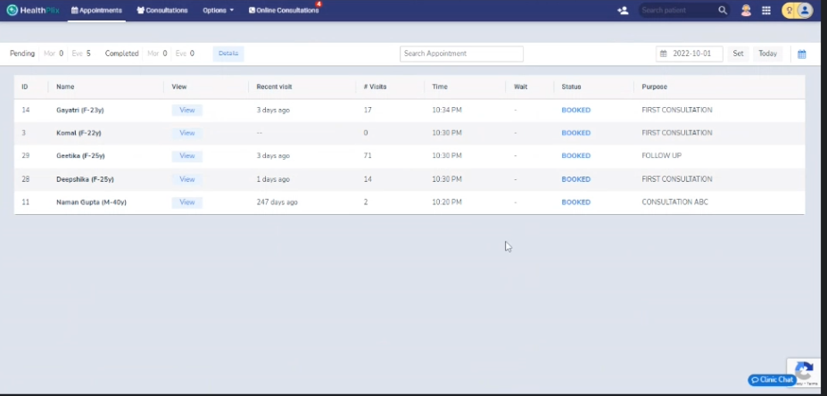Appointment list with shown in calendar mode

* It contain all appointed patient list as per token order. Doctor can view each one as per priority and after do the end session.
* Consider previous consultation history
* Fields
* Sl. No
* Patient Name
* Op No
* Purpose of Visit
* Recent Visit / Last visit
* Time
* Token No
* Status

1. **Consultation**

* Patient Basic Information
* Patient Name
* OP number
* Weight
* Height
* BP count, Sugar etc.
* Referred Doctor
* Diagnosis
* Note all symptoms
* Complaints
* Remarks
* Disease
* Noticed Disease
* Details
* Last prescribed medicines
* Drugs / Medics
* History
* Labs
* All kind of Labs result like BP, Sugar, Scans reports etc.
* Pharmacy details
* Additional Information
* Notes
* To refer doctor
* Next Visiting date
* Case Sheet

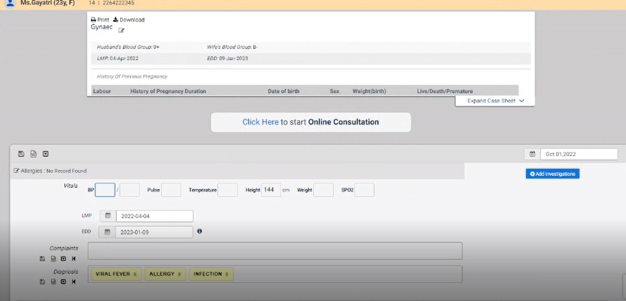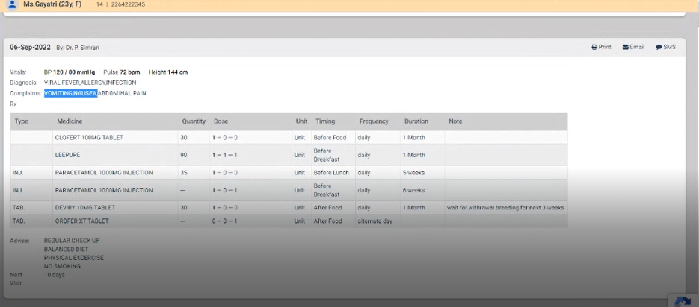

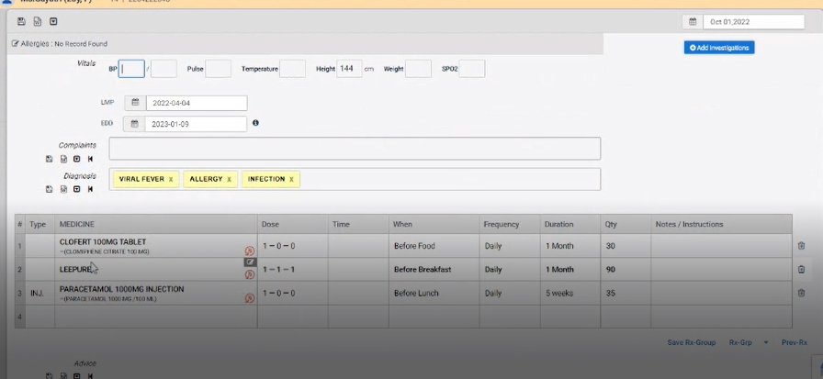

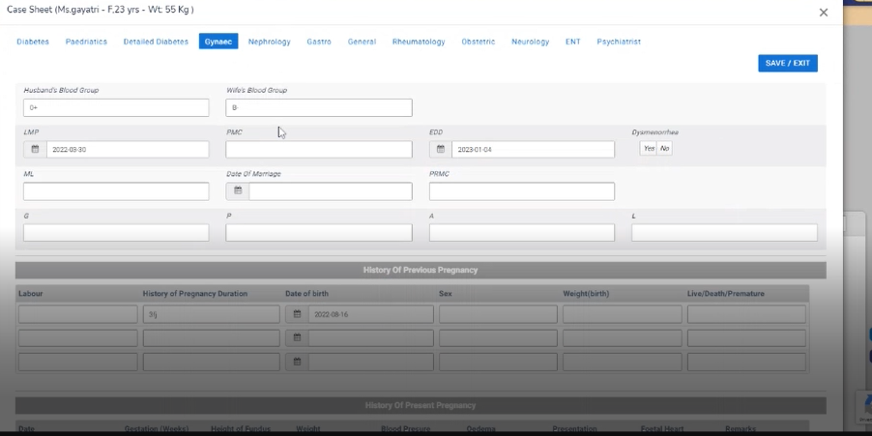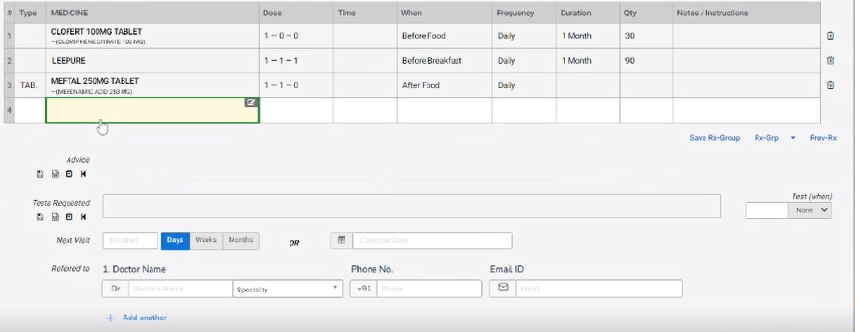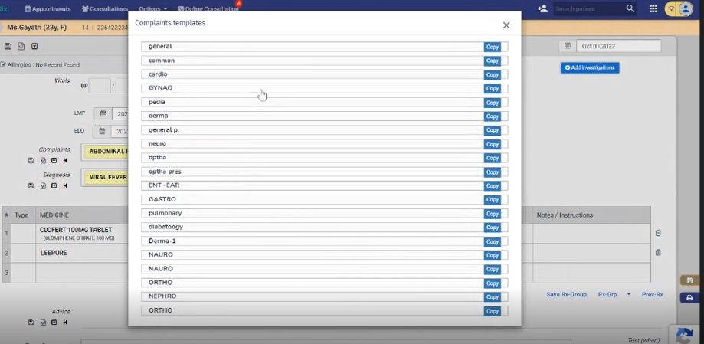

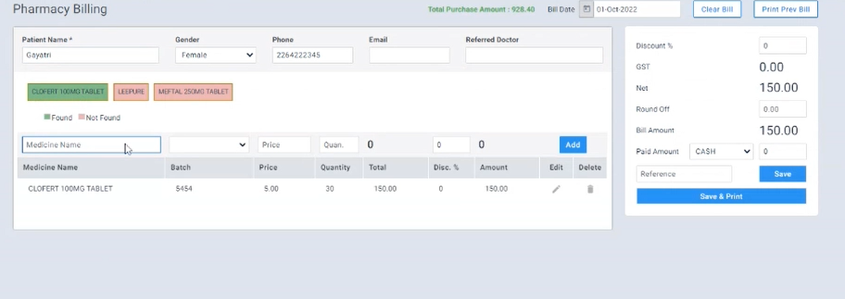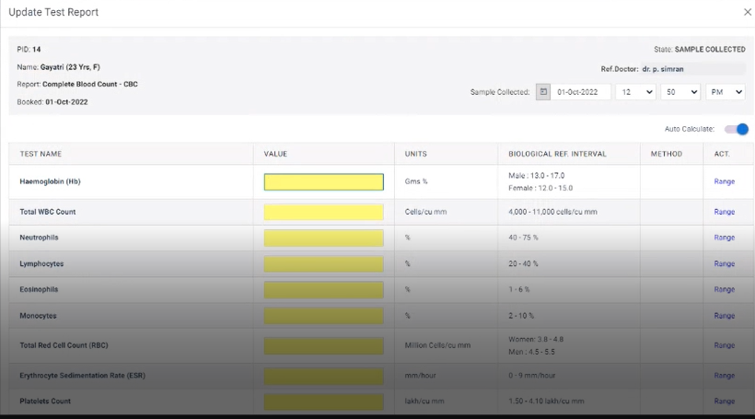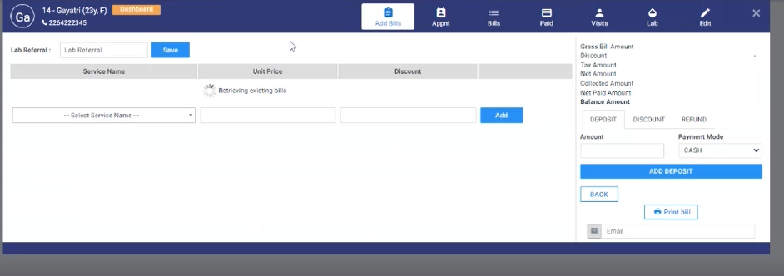

1. **Options**

* 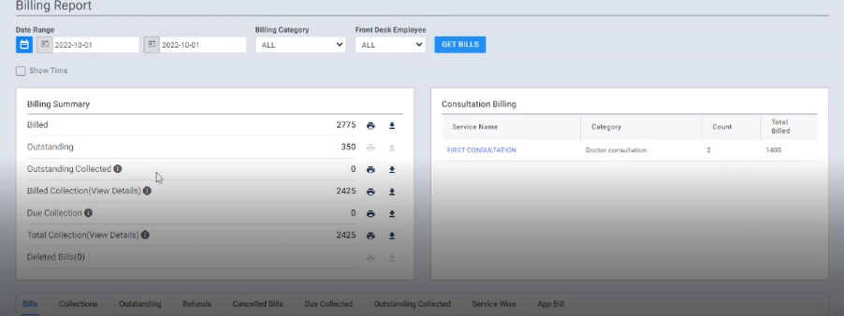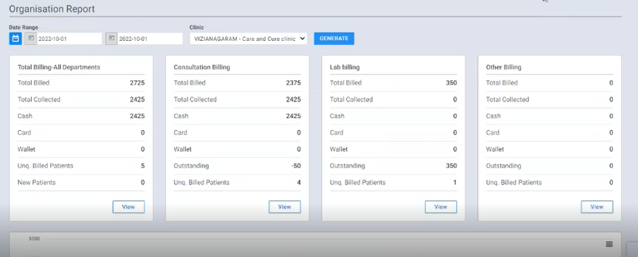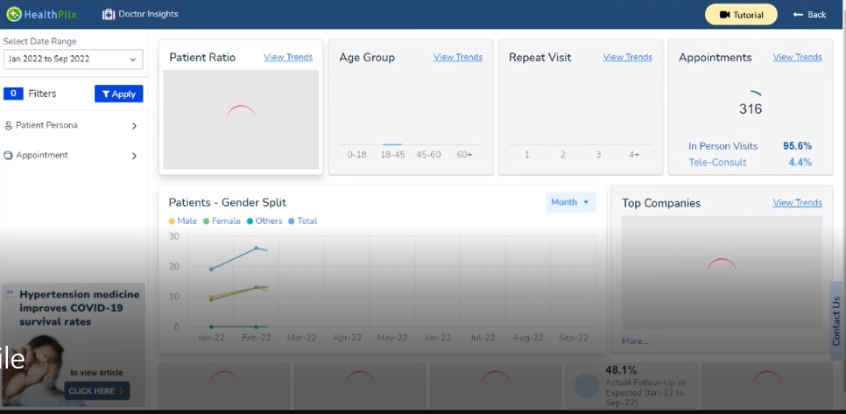Dashboard view

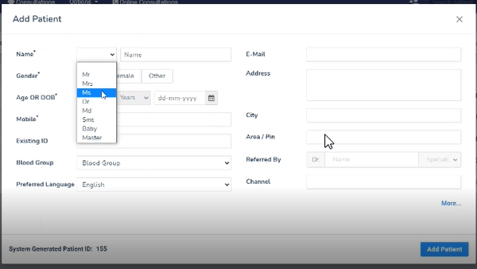

1. **Category change option (Doctor, Lab, Front desk, Administrator and Pharmacy)**
2. **Log out Option**